**Contents**

**X. Index**

**XI. Preface**

**a. Brief History of Halo Online**

**b. Brief History of ElDewrito**

**I. Section 1: Introduction**

**a. General Overview of the Timeline and Canonical Communities**

1. **BK-HB and Subgroups**
   1. **HOC**
2. **Salty Spitoon**
   1. **Brief Summary of its:**
      1. **Origin**

**ii. Era**

**iii. Death and its Communal Effects (BOS)**

1. **Brotherhood of Steel**

**i. Era and Death**

**I.Section 1.5: Overview**

1. **Brief Summary of the Community** 
   1. **Subgroups Timeline and their Canonical Origin**

**II. Section 2: The Keys CFG**

**a. Origin**

1. **Purpose**
   1. **General Expansion on Why The Keys CFG Was Launched**
2. **Creator**
   1. **Niko, TinyDude**

**III. Section 3: Democracy for Hong Kong**

**a. Brief History**

**b. Inspiration/Vision**

**c. Why Democracy for Hong Kong Differed/How They Differed:**

**1. Community Integration**

**2. Map Voting System**

**3. Originality**

**IV. Section 3.1: Democracy for Hong Kong’s Rise and Peak**

**1. Popularity Increase**

**2. Conflicting Servers**

**V. Section 3.2: Democracy for Hong Kong’s Key Figures and Fall**

**1. Administrators, Notable Community Members**

**2. The Anti-Hero and Death of HK**

**3. Other Servers After the Fall**

**VI. Section 4: Zero Gravity Ant Farm**

**1. Origins and Key Figures**

**2. Rise and Potential**

**3. Fall of ZGAF**

**4. Pedophiles and Death of ZGAF**

**VII. Section 4.5 Current Time**

**VIII. Section 5: The Implosion of HB**

1. **Drama**
2. **Discord Group Chat and Conclusion for Now**

Index

1. Beerkeg (BK)

2. HaloBase (HB)

3. Freedom for Hong Kong(HK or FFHK)

4. Arbiter Minigame Server(Arbiter)

5. Zero Gravity Ant Farm(ZGAF)

6. Eldewrito(ED)

7. Tinydude(Tiny)  
 8. Mr Sir Matthew(MSM or Matt)

9. Duck Fudge(Duck)

10. HOC(Halo Online Circle)

11. BOS(Brotherhood of Steel)

12. CFG(Generic preference file)

13. Cvaughn(Webmaster,Market,Weebmaster)

14.Niko(Niko)

Preface

All of the things in this what I would pretty much call a recap of eldewrito history and notable figures throughout the years of drama and debate and discussion. I thought it would be best to archive all of the drama and events that happened to this game's lifespan that make up the playerbase. Pretty much being a historian on the oldest eldewrito server in halo. Especially after being there for some of the main events throughout this recap. Mostly wanted to make whatever information that wasn't public, well public. Been playing this game since 0.5 back in 2017 till now. Wouldn't have been possible without **Niko and Tiny**, Mostly Niko since he still remembers most of the events that unfolded and gave a lot of details and other things and helped out a lot in general. Tiny helped out with the outline greatly and helped out with some smaller details and his own story from his ED bible that he allowed me to combine with this, along with his bible being the main inspiration for this. Dimi,Matt,Sarge and even Duck helped with some of the details for this. Also I(fOrGoT) made this, start scrolling nigga.

History of Halo Online

***Halo Online*** was to be a multiplayer-focused *Halo* game developed by [Saber Interactive](https://www.halopedia.org/Saber_Interactive) and Innova Systems in collaboration with [343 Industries](https://www.halopedia.org/343_Industries).[[1]](https://www.halopedia.org/Halo_Online#cite_note-waypoint-1) It was officially announced in [March 25, 2015](https://www.halopedia.org/2015), with a closed Alpha test that started on [April 21, 2015](https://www.halopedia.org/2015) in Russia only.[[1]](https://www.halopedia.org/Halo_Online#cite_note-waypoint-1) On [December 28, 2015](https://www.halopedia.org/2015), a closed

Beta test was suspended and on [August 24, 2016](https://www.halopedia.org/2016), cancellation of the game in its current form was announced. *Halo Online* was to include "classic weapons and vehicles" from the *Halo* franchise, including the [Hornet](https://www.halopedia.org/AV-14_Hornet) and the [energy sword](https://www.halopedia.org/Type-1_energy_sword).[[2]](https://www.halopedia.org/Halo_Online#cite_note-ign-2) Several new weapons were also to be implemented into the game.[[3]](https://www.halopedia.org/Halo_Online#cite_note-trailer-3) Fan favorite multiplayer maps were to return, along with several new maps—one of which was set in a [Russian](https://en.wikipedia.org/wiki/Russia) town. *Halo Online* would have been optimized for keyboard and mouse controls. Online matches could handle up to sixteen players, with four players being required for a match.[[2]](https://www.halopedia.org/Halo_Online#cite_note-ign-2)

Players were to be able to customize their loadouts, including armor, weapons and abilities. There were several variants of each weapon available for modification. Each weapon featured variants with increased damage, accuracy, and rate of fire.[[3]](https://www.halopedia.org/Halo_Online#cite_note-trailer-3) Unlike most of Halo games, players would not be able to change their armor pieces individually, only as a whole set.

Original Maps

* [Diamondback](https://www.halopedia.org/Diamondback) - a desert-themed remake of [*Halo 3*](https://www.halopedia.org/Halo_3)'s [Avalanche](https://www.halopedia.org/Avalanche).
* [Edge](https://www.halopedia.org/Edge) - a small-team original map to *Halo Online* later ported into *Halo: The Master Chief Collection*.
* [Icebox](https://www.halopedia.org/Icebox) - an ice-themed remake of [*Halo 2*](https://www.halopedia.org/Halo_2)'s [Turf](https://www.halopedia.org/Turf) later ported into *Halo: The Master Chief Collection*.
* [Reactor](https://www.halopedia.org/Reactor_(Halo_Online_map)) - A big-team original map to *Halo Online*.
* [Sky bridge](https://www.halopedia.org/Sky_bridge) - an original map design for *Halo Online* that never made its way into public builds of the game.
* [Waterfall](https://www.halopedia.org/Waterfall) - an original map design later ported into *Halo: The Master Chief Collection*.

On April 6, 2015 the *Halo Online* closed Alpha test started,[[5]](https://www.halopedia.org/Halo_Online#cite_note-5) and a special armor was given to people who played on that day during the Alpha to signify they were there day one. The Closed Alpha's servers were only active for small hours during the day. All players' stats and progress, were wiped after the closed alpha finished on September 11, 2015[[6]](https://www.halopedia.org/Halo_Online#cite_note-6)

On August 24, 2016 Innova Systems announced that Microsoft Studios still had not made a decision on the project's fate, and the game would never be released in its current form, making the project's fate uncertain. Therefore the publisher is shutting down the game's website and the page on social network vk.com.[[8]](https://www.halopedia.org/Halo_Online#cite_note-The_end_of_Spartan_era-8) The community manager of Halo Online stated that "such a project most likely won't ever exist at all, but only time will show", answering the question if the game is suspended indefinitely.

Yea nigga i got this all from <https://www.halopedia.org/Halo_Online> who cares

Brief History of Eldewrito

During the testing phase of halo online, a group of modders were able to download a build of the game and began to work on Eldewrito, pretty much a fan made thing to bring halo to pc by modding the game. During the years they began to release different versions like 0.5 during january 2016. 0.5 is where the game started to be known and gain a playerbase. During this time the game was rough and the servers and maps were pretty shitty but fun in retrospect. During 2017 0.5.1.1 released and that's when more players joined it became a bit more public and easier to find . The maps and forge were still shitty but fun.

On April 20th, 2018 the modders released 0.6, it was amazing seeing and playing halo on PC with community members hosting their own maps and gamemodes. With a playerbase of 10,000 players. After four days and during the brief popularity 343 Industries asked the modders to stop development of the game(can’t remember if they sent a cease and desist or not), this ultimately scared away a lot of players since they thought the game was illegal or something else and public downloads were mostly taken down. This ultimately made the game niche and hard to find which is why the playerbase tanked and never truly grew. After this there were about a couple hundred players left and the numbers dwindled each day to where it is now. This is where the small community forms and sub groups of the community happen.

General Overview of the Timeline and Canonical Communities

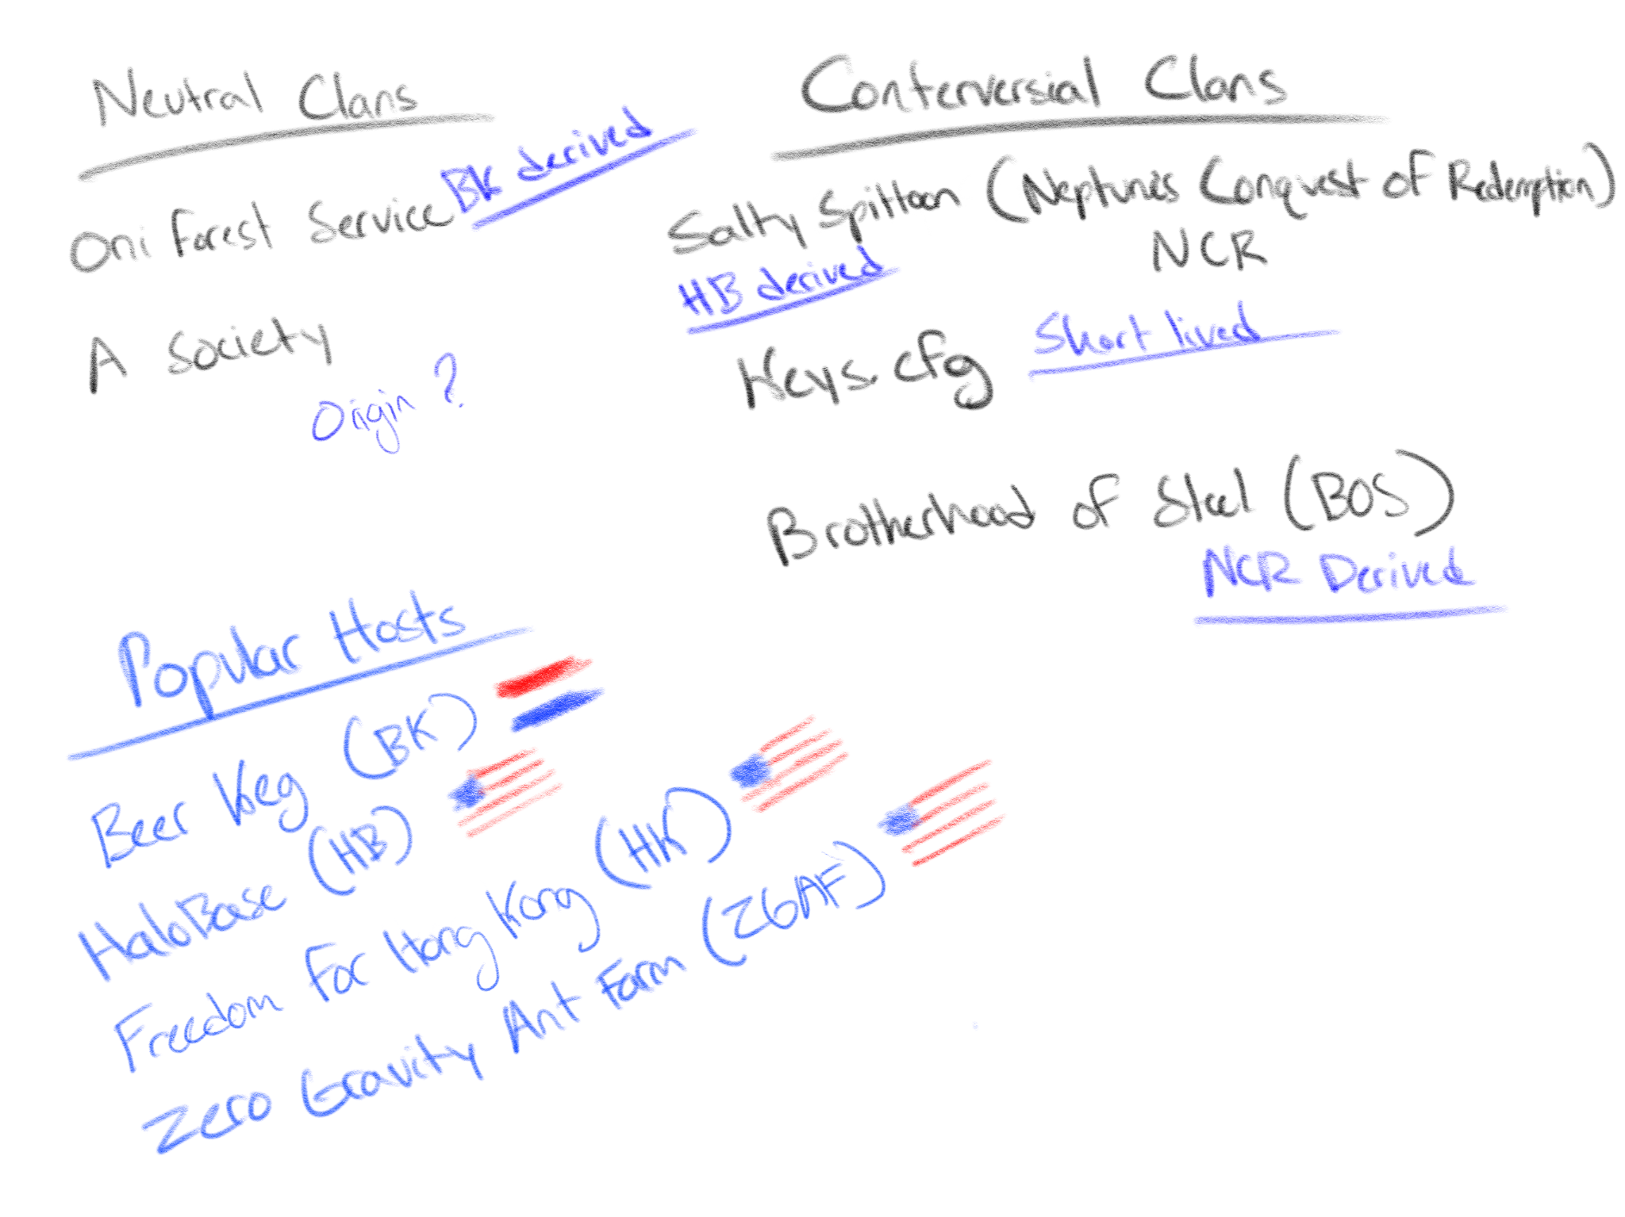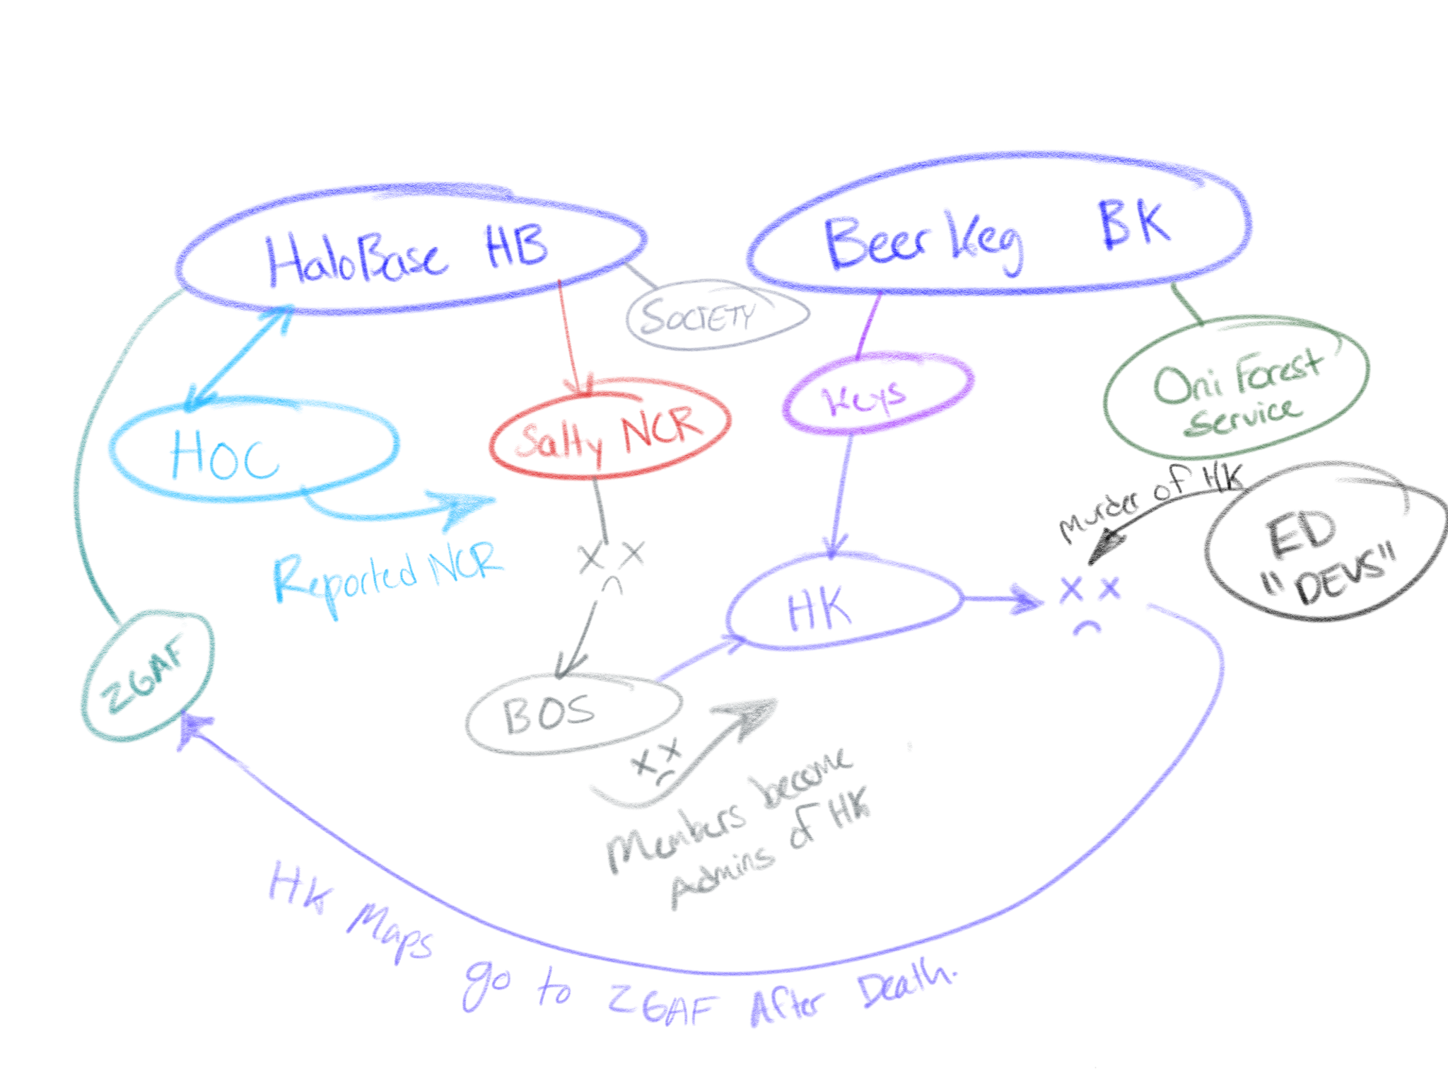

(Images made by Niko, Through 2018 to 2022)

BK-HB and Subgroups

Beerkeg was one of the first big minigames servers on eldewrito, and was the one of main ones people played. It had a pretty big community because of the sheer variety of maps and gamemodes. It had alot of classics that brought people to the server(you know what im talking about nigga).But it is also one of the first servers people play on for minigames. The community holds some importance since it was a middle ground for a lot of the sub communities in eldewrito. Since the discord server was dead most of the time and the mods were chill. Warm was also the person who made beerkeg.net where you can upload custom emblems,ranking,EXP, K/D and much more information.

(<https://thebeerkeg.net/index.php>)

HaloBase was pretty much the main minigame server, its good minigames and somewhat small selection was good but small. It was the main minigame server for a lot of reasons, one of which was ping which is one the main factors in ED for a lot of basic reasons. Like swords, absorbing bullets,nades,shooting people coming up a lift, the usual. HB was hosted in US bumfuck nowhere so it worked for majority of players and fucked over any annoying EU fag. Another reason was literally one gamemode that defines ED, is “Fatkid”. This shit was like crack to low income neighborhoods to ED players. Some neurons went off and it just hit, also it being a fun infection gamemode helped greatly. Another gamemode was Castlewars or CW for short since it was a sword only gamemode with sticky grenades. It was very popular for being fun, aids, annoying, losing because someone has better ping than you, rage inducing game mode since sword fights were decided by ping most of the time. Another one was Gladiators but I still have no idea why it was that popular till this day. So basically Infection, CTF, Good Ping and Fiesta = Niggas likey.

HOC was basically the cool kids club for top and good players on HB. It was made by Dito. You were supposed to become a member only through being known as a good player but the rules got lax with time. They also had a separate server and also a private chat in HB. Really the pivotal moment of everything honestly was Cats and Goat being banned. HOC was the moderating force behind it. They were always out to get cats and goat especially. They watched until they had a reason to ban. They wanted a real reason so there wouldn’t be too much fuss but there was still fuss in the end. Salty Spitoon rose in the shadows inviting people not for how good of a player you are but just how based you were, kinda more independent then eldewrito based.

Salty Spitoon

(This section is written entirely by Tiny from his bible during 2018-2019(with some edits from forgot))

So, the "beef", if you will, between Foozo and I, TinyDude, initiated by Foozo, started on Castle Wars 1.5, in a game where I defended Sarge for spamming flag drop and pick up. This is where things went downhill. Foozo, for a few weeks prior, had already shown distaste towards me, for no given reason, but this particular instance starting on Castle Wars is where it got memorable. Foozo's anger had sprouted from a server initially made out of spite to HB. The server, Salty Spitoon, being started by lain and Cats, was seen as a threat to HB, at least from Foozo's perspective. This server was mainly where I, Cats, Goat, and eventually just a few others would talk about our frustrations, in a vulgar manner. At this point in time, we trusted Foozo, he was a good friend who was always kind, as well as a fair moderator for HB. Inside the Salty Spitoon, there was a channel called #Octagon was always in the Discord server, but was open to all members of the Discord for a brief period of time. In this channel, we would talk badly about others, and joke around in ways that were best kept private. For instance, we would make jokes about Duck, like calling him a jungle nigger. Foozo had a slight glimpse of this channel before it was made private, though we can only assume that, because the information he knew and would tell others, masking it as truth, was only said in this Octagon channel. Foozo spread the word of this channel, and the Discord as a whole, as a hate-mongering Discord, and told others that this Discord server needed to be watched closely, and that I, specifically, needed to be dealt with. They ended up, ultimately, dealing with me, and they dealt with me in a rough manner. The Salty Spitoon was not what Foozo made it out to be, though. In the beginning of the Salty Spitoon, granted, we did hate quite a bit, but it was in a private setting, gathering only with people we trusted. Foozo was invited a little after we would talk such trash, but we didn't purge any of the channels, nor did we make Octagon channel private quite yet, though very soon after we did. We eventually cleaned up the Salty Spitoon Discord, but some channels were not purged, mainly the #general channel. We didn't purge this channel for quite a while, this is where I believe Foozo got most of the information that he would exaggerate and take out of context, and then go on to spread it in admin-only channels. Foozo would also directly message higher ups, such as Duck Fudge and Hambone, as well TriMrDito, about what he would read in our Discord, again, taking things out of context and exaggerating. In the Salty Spitoon, we had a few rules, one of them being to not turn your back on fellow Patrons(Patrons being the members of the Salty Spitoon). After we caught on to what Foozo had been doing, we banned him from the Salty Spitoon for violating this rule. Soon after this, Foozo started to take things a little more seriously. These chat logs refer to the time around when Foozo stopped using his usual in-game name,

Foozo(https://cdn.discordapp.com/attachments/650565697650556928/671573729444364288/ Server_2_chat.txt). These videos are also around the same time, if not the same time:

<https://www.youtube.com/watch?v=bx4x8PncgPM&feature=youtu.be>

<https://www.youtube.com/watch?v=IIT_szLlmL0>

Foozo was attempting to mask himself under the alias of various different player names, though he failed to change his UID each time, causing it to be easily known who he was each time.

Foozo stated that he went undercover as per the above alias(the links don't work anymore) to supposedly catch a player by the name of "magik" hacking. His attempts were rendered futile every time, though, as magik was not a hacker. I was also told from another source aside from Foozo that he wanted to hide from Goat and I because we were harassing him in-game. This was untrue, as well as the opposite. Eventually, this drama got tiring. It would stay silent for a while, then come back with something else. So, Cats and the rest of those of high profile in the Salty Spitoon decided to invite Duck Fudge into the server for a brief time to finally settle things. Duck joined, but didn't say anything for about ten minutes. We interacted briefly and thought we might have settled things. However, during the ten or so minutes that Duck was silent, he was gathering screenshots of out of context messages to get the Salty Spitoon Discord server removed from Discord, along with our accounts.

This was accomplished by Duck Fudge, encouraged by Foozo. Statement from Duck Fudge: "Foozo, as you know, felt bullied and intimidated by NCR He constantly claimed that NCR was after him Hence, he changed his names ikon, toad, and a few other names He kept rotating so he wouldn't be found I even taught him how to reset stats to keep away from you guys because I trusted what he said So when he told me that it was getting too much, I gathered evidence of racism from the Spitoon server and reported it to Discord T&S I did it because I wanted to protect my friend He still continued to make claims against you guys and we believed him He claims magik and Matthew are hackers When we finally got disillusioned from his shit he was removed from HOC's high council He then left HOC on his own terms as well as HB and every other server Since then, he's attempted at cheating, generally trolled a bit, and started unnecessary drama on servers I'm sorry I did what I did, but I want you to know I did it to protect a friend who to my knowledge at the time was the victim TriMrDito is not at fault for this I acted on my own" Another statement by Duck Fudge: "I looked at Foozo as one of my closest friends and a brother. I did it to protect him without realizing he was the one tearing us apart" This is a folder containing the out of context evidence that Duck Fudge used to report us: https://cdn.discordapp.com/attachments/650565697650556928/671607794041880587/ Spitoon.zip. Something to analyze here, in Duck's first statement, nearing the beginning, is his mentioning of the NCR. The NCR was an Eldewrito clan made by Cats during the creation of the Salty Spitoon. NCR stood for Neptune's Conquest for Redemption. The meaning was initially meant to be kept silent, though we mentioned the meaning of NCR in the un-purged #general channel of the Salty Spitoon. Everyone in HOC believed that NCR was a hate group targeting HOC members in Eldewrito. Though for the most part no members of the NCR targeted any HOC members, there were instigators. However, I was not in NCR, though Foozo had everyone to believe that I was. I stayed loyal to HOC and did not live two lives. I merely moderated the Discord server that the NCR clan had met in. Although, I was on good terms with those in NCR, as well as I was on good terms, for the most part, with HB and HOC higher ups, aside from Foozo, and Duck. Though at the time, I did not know that Duck wasn't on good terms, though it came off as if we were. The termination of the Salty Spitoon was a major blow to Cats and I, as well as it was to our Discord accounts. Ultimately, Foozo came out the victor. The Salty Spitoon was terminated on April 6th of 2019, three people lost their Discord accounts as well, including Cats, Soda, and I(TinyDude). For a while, it had gone silent, Foozo still existed, and would instigate conflict in-game, but ultimately, for the most part, we would all ignore his attempts. Everything Cats and I and with the other admins had built up, was nothing but futile in the end. Coincidentally, magik, the player wrongly accused of hacking by Foozo, was one of high profile in the Salty Spitoon, and we allowed him to take part in our private #octagon channel, which at this point was essentially an admin chat, though it still consisted of the usual banter as well. Magik had created a Discord server a few days prior to the Salty Spitoon's termination, the Discord was called The Brotherhood. The name was based off of a joke that we had in-game, where magik, Goat, and I, would welcome each other by putting "brother" in front of each other's names, resulting in names that had ended up being used in-game as real player names, like "Brother Goat" and "Brother Magik". (Tiny’s section ends here)

Brotherhood of Steel

The Brotherhood Discord server sprouted an in-game clan, called Brotherhood of Steel, shortened by BOS. This was a Fallout: New Vegas reference. The BOS had brought on troubles, inevitably. Two salty individuals by the name of Jared and Soda, along with a Discord user named sa7an, had talked about doxxing other individuals, as well as DDOSing the Eldewrito master servers. This was seen as a threat to Eldewrito as a whole, and was taken seriously. I, along with the others in the Brotherhood Discord did not partake in the threats or general talk of DDOSing and doxxing, it was solely the individuals mentioned before(Jared, Soda, and sa7an). This interaction in the Brotherhood had obviously put us in hot water, though the admins of the Brotherhood handled it swiftly, by restricting the talk of doxxing and DDOSing in the Discord server. Members involved in the threats were muted and, ultimately, kicked. Their kicks, though, were not rooted in spite, we just wanted to clear anything up before it got worse. Because from past experience, it was doomed to get worse if not dealt with. Going back to Foozo, he has since stopped playing Eldewrito, as far as we know, and has left his position as moderator in HB, as well as leaving HOC. He did this not too long after the creation of BOS, but it did not happen immediately, either. BOS died a slow uneventful death of it being inactive and then magik deleting it.

Overview

Basically during this time the timeline goes like this:

***HB(HOC)<Salty Spitoon(NCR)<Brotherhood of Steel(BOS)*.**

All of these subgroups either originate from the HB community itself or the HB’s subgroup HOC at the time along from different drama periods.

The Keys CFG

So Niko and Cvaughn were chilling in BK 5 feet away so its not gay. Then they decided to make a server called ‘keys.cfg’ as a joke. That joke eventually rolled in a ‘keys war’ as Niko calls it. Niko and Tiny used to move the server to different states, countries just to avoid a ban. Eventually ED developers made an entire api to ban them because they got so tired of chasing them around. This mostly happened because they had A LOT of beef with how the ED developers operate. But after a while it got tiring and tiny and niko wanted to settle down.

Tiny wanted to form a community but they wanted to start it with a new name. That name was Freedom for Hong Kong(FFHK) which Niko gave. Niko went more into the background doing this and let tiny form the community he wanted to, which he was starting to plan. Keys was pretty much the predecessor for Hong Kong.

Section 3: Democracy for Hong Kong

Democracy for Hong Kong was a server made after the death of BOS and the events that happened in the key’s server. Niko was one of the main server hosters, cvaughn was another one. It was made for new fresh ideas for eldewrito servers and global banned players. Another idea from the admins of HK was to not intervene unless it was a hacker or a total ass in the game. They allowed the community to decide if they should be kicked or not. Along with that Hong Kong had no “rules”(well it did have a couple to stop annoying niggas and other things that would otherwise ruin the server).

Hong Kong also wanted to show how a server should properly be run and how they should interact with the community. The inspiration was probably from the way HB and BK were run with them not having any rotation changes or map updates, and not interacting with the community to see what they could improve. HK strived to do this in a way that was perfect. While BK and HB became very stale and annoying playing the same bad modes or maps.

The community integration worked because of discord and the fact they had forgers in the server. So you could get people who could constantly update or fix maps or create new maps entirely. Discord solves the issue of communication. But forgers also need a playerbase for people to test and play their maps, which HK provided. HK also provided a way for players to decide what they want. The system was a Map Voting System (MVS) on discord there would last a couple weeks depending if fucking vlad remembered. Then the server admins(Tiny,Goat,Matt) would update it. This system worked well because it gave new forgers and new maps a chance to be put in and played in the rotation. So it always kept fresh and never got stale unlike other servers at the time, which was a major problem at the time. 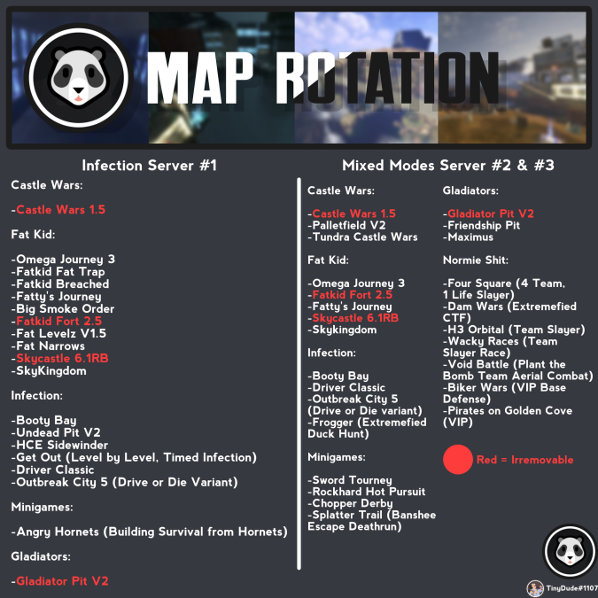

Section 3.1: Democracy for Hong Kong’s Rise and Peak

When Hong Kong first opened it gained popularity for its fresh maps and community members. It was also a competition for HB so people wanted to see what it offered to minigames in general. It offered above and beyond with its new maps and modes. Compared to HB, HK blew it out of the water in every way possible. Community, active forgers and playerbase all added together HB didn't stand a chance. It blew up in popularity and it allowed global banned players to play on it as well. This allowed even more players to join and play on HK. Which overall boosted popularity in general across the board. The biggest increase in players was when HB went down for a couple weeks. Along with this BK went down a long time ago so realistically Hong Kong was the only (good) minigame server at the time. So basically everyone flocked to HK. But some people didn't like Hong Kong and its founders a lot so they set up something.

That something was Arbiter’s Minigame server, they had about 8 servers to fill up the list on eldewrito. Arbiters was hosted by an “unknown” person in the community. The server was a mix between HB and BK maps and modes. Which means it wasn't very good and a lot of the maps were not updated or very old ones. It was up during the HK time period from when it got popular to the day it fell. The main theory was that ED developers hosted the server because they didn't like HK being the main popular server due to drama with the founders. This ‘theory’ is not really a theory when you truly think about it and the amount of ‘coincidences’ it had like certain maps that weren’t publicly available and 8 servers being hosted, along with it somehow seeded at times. Alongside the server owner being unknown we can pretty much assume it was an ED developer that made a plant CIA server to combat Hong Kong popularity, because it went down at the same time HK, and HK still had beef with devs at the time.

Section 3.2: Democracy for Hong Kong’s Key Figures

Freedom for Hong Kong had a bunch of active community members that benefited and provided to the community at large. I'm pretty much gonna go down a Hierarchy for the main community members that had an impact. The First ones are going to be server hosters, administrators and moderators. The main founder was Niko, he was the server hoster that ran it at first and started HK along with another person later on which was cvaughn. The founders also include some of the administrators, these administrators were TinyDude,Vlad,Goat and Matt. Vlad was pretty much the equivalent of a manager for HK. He had no server access but would take care of things in the server and settle debates or give out punishments to people as well as give updates on the server. Matt was an admin that would help out in the actual server, like the rotation, help and other things. Matt's main role was being one of the best forgers in Eldewrito, he would help other forgers test out their maps and give tips for forging. He would fix up maps or make new maps for the playerbase and would help with server related things. His past experiences of being an admin was overall helpful to the community at large. Goat was an admin who pretty much handled the retards and would be there if Matt or Tiny werent on at the time to kick a hacker orother admin stuff, he was also a forger as well and a fucking degenerate. TinyDude was one of the core founders of HK. Tiny was the one that wanted to form a solid community and bring new and original ideas to minigame servers. He was the main factor in making sure the rotation wasn't stale, server updates, and other admin things. Other Notable people in the community would be: Bunz, Tpf, Toge,(Tushar maybe). Bunz was an active forger who would create new maps or fix up other maps, pretty much did the same things as Matt but without the admin stuff and being a midget. Tpf was a person who would constantly find ways of breaking out of maps and showing them to the forgers and breaking out again, pretty much a playtester and drove forgers insane. Toge was a ‘forger’ who would forge maps for eldewrito, they weren't really good.

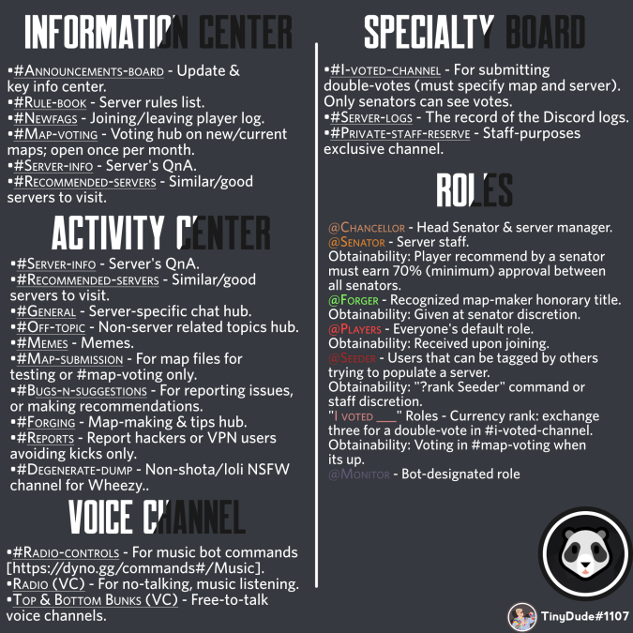

**The Anti-Hero**

Weebmaster was a real homie, helping out with A LOT of things in HK. He was one the main reasons it was to compete and thrive overall. He was the reason it was up and running most of the time. He ran 2 out of the 4 servers, stole useful stuff from other developers and eldewrito servers. Would help maintain HK along with writing programs for it. He would run his part of his stuff outta his own pocket. He would also make the programs free that would automate restarting the server and making a UI for it. He also made an UI for loading maps as well. Generally a server isn’t hard to run but as we had a few of them he helped with keeping the IPs routed correctly. If a server went down or was crashing Niko would harass him for help. Nigga was basically a modern robin hood by stealing stuff and giving it the community. But one day he stole something that he shouldn't have and he knew he shouldn't but he still did in the end. Weebmaster had an anti cheat dll that apparently he wasn't supposed to have and is reserved for official servers only, supposed to only be given out by official ED devs/mods. This dll logs suspicious actions, and can kick as well. Weeb and Tiny realized that it was triggering when it shouldn't be, so they decided to download aimbot hacks to test the anticheat, and compare the hacked trigger values to false positive trigger values, but this dll communicates with an API of theirs, and they found out, and blacklisted HK from the browser and globally banned Tiny. Tiny got un-globally banned, but at the cost of shutting down the server. They weren't going to un-blacklist the server, so it was worthless to try and keep up, because you can only see it with a third-party browser, which the majority of players at the time did not have. So Hong Kong fell and shut down for good on 08/30/2020. This was the end of the community at large because most didnt want to downgrade or were already global banned or simply stopped playing all together, this is basically the death of Eldewrito and the game never recovered. Honestly this is equally Tiny’s and Webmaster's fault when this occurred. Webmaster was known at the time for fucking people over if he had any server access and would build up trust and then burn bridges. Tiny got multiple warnings over the time HK was up but for the most part ignored it until the anti-cheat fiasco happened. Since at the same time Webmaster helped with server related stuff. Even Niko trusted him because he was so helpful, it's hard not to see him as anything other than a turncoat but when you read about all the stuff he did it's not hard to see why Tiny ignored the warnings and why he wasn’t trusted in the community anymore, ultimately Tiny payed the price. But even with the beef they had, banning a server for an anti-cheat that should be available to trusted server hosts is the definition of being petty. They even refused to talk to Tiny when the server went down and only contacted him through Matt like gods and Matt being the prophet. Webmaster is a loser faggot didn’t say anything before he left HK and went to ZGAF. So he did know something or just dipped like a fucking faggot spook pajeet loser who should be publicaly hanged for a being a loser and detriment to society as a whole he serve’s no purpose Nigga go be a sheriff a cop do something with yourself Cuz you're wasting time My guy and it might not be me but some nigga's gonna get ahold of you some nigga some nigga in parenthesis(ME) and gonna manhandle the fuck outta you or worse see if I got a hold of you I'm gonna try to break some sense into your black crispy burnt ass. If you ever see the guy in discord call him every slur you know please he deserves it.

Other Servers After the Fall

After HK fell ED was truly in shambles for a period of time with most players simply just leaving the game and to never come back again. Minigame enjoyers had no were to go because there simply were no good Minigame servers to play on instantly. HB wasn't updated at the time and BK went down a long time ago. Any other server was some dogshit old one that had outdated broken maps. There was one server that has been on and off for awhile called “Appeal to Heaven '' that was similar to HK in alot ways but no one knew was hosting it and randomly comes back every once in awhile. There was one server after the HK fell though and looked to be the next popular minigame server. That server was Zero Gravity Ant Farm hosted by Buckaroooooo. Thus we entered the era of regression and collapse.

Section 4: Zero Gravity Ant Farm

Zero Gravity Ant Farm was hosted by buckarooooo when HK was up actually but saw very little use in general. Mostly a side project thing for buck during the time if I remember right. After HK went down tiny gave all of HK maps to buck. Then ZGAF looked to be the next popular minigame server and players flocked to it. Buck was the main admin of the server, Rhen was a mod/forger for the server and discord. These were the main two keg figures for the server. So then came ZGAF.

ZGAF honestly at the beginning had a lot of potential and basically had no competition at the time so it rising to popularity was fairly easy. Having a server in the US with somewhat decent ping. Also having all of Hong Kong maps at your disposal, making a good rotation real fucking easy. No competition because HB was doing nothing at the time and players had no were else to go. So with all this you think Buck would basically make HK but in his own vision but nope.

Buckarooooo instead used none of the refined and fixed HK maps and instead used broken old maps, new maps that were never tested properly or fully finished. This led to a lot of problems with broken maps and people either abusing shit or breaking out. ZGAF community members also would steal maps and retexture them. Webmaster did some forge tools but nothing else really since he wasn't really trusted. Rhen would abuse mods powers in discord and put you in brazil for minor shit. Would also punish you if you did something to another user in a different ED server(<https://bit.ly/3yQ5Pan>). ZGAF also brought a lot of annoying niggas in ED that i dont even remember other than the fact other than they were annoying. The cherry on top of this was a player called ‘Grabisoft’. They were supposedly 10 years old who somehow found ED on the internet online and played with a mic. The drama surrounding this person was how a 10 year old found this niche game that had all public download links removed, didn't know how to play and would talk all the time in voice chat. Basically some players came to a conclusion that Grabi was a 40 year old man in a basement pretending to be a ten year old online. But ZGAF community defended Grabi like white knights. ZGAF players would also bend rules in Grabi’s favor. Like teaming in gladiators would mostly like get you kicked but if you were Grabi? It was fine and no punishment. Players would also do everything for Grabi no matter what gamemode. This was generally frustrating since if you weren't grabi you were kicked. But small communities always foster freaks on the internet that you can't get rid of.With all these things combine ZGAF fostered a god awful community at large. Some of this was how Buck and Rhen managed the server overall in a kinda bad state but it wasn't fully their fault. It was the community then made and failed to manage fault. Which was the main problem with it overall. Which led this awful community into eventually having pedophiles.

ElDewrito, also referred to as ED, is a mod for a video game. Based on the information provided by the FBI, the government understands that it is common for pedophiles discussing their predatory activity online to refer to such activity as “Playing ED” to conceal the nature of the activity. A Certain sub community hosts a server named “Zero Gravity Ant Farm '' seems to be the main hangout for these individuals. The name of the server owner is ‎REDACTED. These Individuals hang out in their discord and discuss all types of things. Trying to speak up against their criminal actions results in a ban and global ban ingame. This means they have a dictatorship over the game and expunged any player who speaks against them. This along with the fear mongering makes players scared to stand up to the admins because being banned from the only active server left in the game during the time. MT, Braindead, and otherSaucy(Justin,haha),inconistent were all confirmed to have had other usernames and comments involving grabi in sexual/explicit ways. They call themselves the pedophile trio. The problem is that the ZGAF has no ban list. So they were eventually able to rejoin again and again until they were globally banned for explicit grabi names and texts. Buck for the longest time denied it was a problem and refused to take action on it. Since all of the evidence is in screenshots I have decided to compile them all into one google drive folder since it will be more efficient to view them that way.

<https://drive.google.com/drive/folders/1AcWgZi6oal51OUJr1VQf2ytwWsCy1xpM?usp=sharing>

Tiny regrets ever giving all the HK maps away to buck for how he managed overall and I had many arguments with buck about ZGAF back in ONI (only real niggas know) before he left it. Used to know the nigga back there and he mostly was chill and cool, in the end I don’t fully blame him for the situation that ZGAF created since it was alot of factors playing into it. In the end ZGAF shut down for unknown reasons on 07/06/2021.

Section 4.5 Current Time

Current time is basically ED in the state it is right now. So after ZGAF went down HB after a while got their stuff together overall and decided to fully ‘revivalize’ HB. Hambone took a step back and basically gave most of the power to Duck so he could run it. Then the duck gave more power to Matt since he didn't know how to do the rotation and other things himself. This was perfect for Matt with his past experience in HK on updating and changing the rotation around. Along with him being pretty much the last ED forger it worked out well since he could test new maps or update/fix other maps. Since HB was the last ‘popular’ minigame server they got their shit together and overall made it good. Welp that comes to today was around a base of 16 players at max. Dwindling each day slowly, still the same old ED where you can have fun occasionally with way more retards in the game. Eldewrito is truly one of those games of all time and one of the best experiences I've had in gaming. This really was an Eldewrito….

The Implosion of HB

This drama all started in an HB lobby on 10/12/22, so me(forgot), sarge,goat and Crusader were trolling Bonepurse in Fat kid Levelz. Bonepurse didn’t like us saying ‘faggot’ and we decided to spam chat with it to annoy Bonepurse. We did this until he reported us to HB discord report-players for saying faggot. So me, goat and sarge started trolling him in report players. Then the discord mod Pauwlo stepped in to tell us to stop ‘spamming’ report-players. So, I decided to push the limits a little bit and I put ‘FAG 1984’ reactions on his message(<https://bit.ly/3TDKc5c>). Pauwlo at this point is just malding looking for any reason to ban us. So he bans me for those reactions. He then turns off reactions in report-players. Then Tiny got banned for calling a him a French frog faggot and asked to be banned. After it happened, I sent Pauwlo IP(82.64.143.33) through the prophet known as Sarge. So about a week later me,goat,crusader,tiny and sarge we’re all in a VC playing ED vibing. Niko joins later on in the fun but not in the VC, so we're all playing ED until the topic of Pauwlo comes. We all except Sarge and Crusader talk about how much we hate Pauwlo. Bonepurse reports again for a second time and Pauwlo comes on at 3am to moderate on an Eldewrito Server. Pauwlo joins underneath a random name and color and joins right at the time we're shit-talking him and then me and Niko have the same thought and post his IP in chat. Pauwlo after watching sends a message about cleaning up chat and bans me, Niko. Goat gets banned a little later for mocking him in HB with a clown emoji and then gets banned with us for shit-talking in game(<https://bit.ly/3VRUWz1>). For some reason, Pauwlo thinks me and Goat are Sarge’s goons, and he controls us, so Sarge and Crusader were ‘guilty by association’. Niko keeps joining but getting kicked every 15 seconds no matter what he did, Goat changes his IP and keeps trying to rejoin but gets kicked since Pauwlo had an Auto Kick Tool on the server. Eventually we all get tired and go to sleep. Then late at night, Duck randomly makes a Discord Group Chat.

Duck made the Group Chat called ‘Banned Bin’(<https://bit.ly/3Dm8SKp>) to inform us all at once about the topic and get our side of the story. Duck also did it because he’s seen drama destroy the playerbase time and time again and didn't want it happening again with this small of a playerbase since it would be the final nail in the coffin for ED as a whole. The members in the GC were: <https://bit.ly/3Stov6N>. Because our messages were conveniently mass deleted so there were no logs, which is why he needed our accounts on the situation. We talked about Pauwlo and the way he moderates and how he handles shit-talking very badly. (<https://bit.ly/3eVZIuI>). Duck the next day writes out a compromise for us to agree on and have a mutual relationship with Pauwlo where we wouldn't interact or ‘provoke’ him, and he wouldn’t interact with us. In return, Pauwlo wouldn’t interact with us including moderation and any further bans would get immediately deleted. The goal was co-existence and no interactions between us and only acknowledging each other when necessary. We didn't exactly like it at first and argued about different points of his moderation. But Duck couldn’t exactly do much and told us what he could do overall. He also told us a detail about there being another secret moderator but wouldn't tell us who it was, I came to the conclusion that it was an ED developer backing up Pauwlo from my own theories. We eventually got an extra clause on making pauwlo block us , so he could properly never interact with us. We all

“Agreed” to it, except Tiny since he didn't want to dance around pauwlo and didn’t care about being banned from HB. Duck accepted that answer and we also added that his Auto Ban Tool be removed from the server as well which he agreed to and removed (<https://bit.ly/3VNKxUQ>). After the discussion was almost over except for the detail duck told us of Pauwlo losing his RCON access which we all were all glad for. After this point the discussion is officially over, i'm going to talk about one more thing Duck actually confirmed for us. You don't need to read this part if you want. But Duck basically confirmed a theory for us. Pauwlo has a sky net which is basically a mini global ban. It only works for servers he has access to and RCON(duck skimped around the topic) which includes HB. The theory was how is a non-admin person able to kick people on servers he’s not an admin on. When Duck said the information, it basically confirmed that it existed. <https://bit.ly/3VNKxUQ>